Shri Ramdeobaba College of Engineering and Management, Nagpur
Department of Computer Science and Engineering
Programme |  | B.Tech (CSE) |  |  |  |  | Year | 2025-26
Semester |  | IV |  |  |  |  | Section | A1 to A9
Course Name |  | Software Laboratory-II |  |  |  |  | Code | 24CS01PR0404
Course Coordinator(s) |  |  | Dr. P. Pardhi
 |  |  | Dr. S. Rawat
 |  |  | Er. Nupur Jaiswal, Er. Sagar Tete

List of Experiments
Sr. No. | Aim / Problem Statement | Mapped COs | Remarks
1. | Study of Android Development Environment & Develop “HelloWorld” application that uses GUI components, Font and Colors, and demonstration of activity lifecycle methods. | CO1 | N
2. | Design the User Interface for the Health Checkup page using the following Layout.  1. Nested Linear Layout  2. Relative Layout  3. Constraint Layout  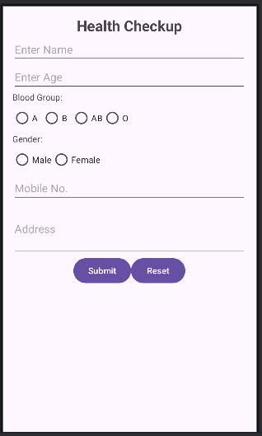 | CO1 | N
3. | Demonstrate use of Event handlers for creating a responsive  android application.  Online Food Ordering App Aim: To build a responsive Food Ordering Android application where the submit button is enabled only after the user enters delivery details and selects at least one food item. On submission, a toast displays the selected food item(s).  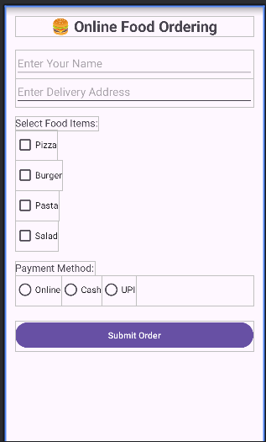 | CO2 | N
4. | To design and implement a responsive Hospital Appointment Booking Android application using ConstraintLayout, where the Book Appointment button is initially disabled and becomes enabled only when all required fields (Patient Name, Age, Mobile Number, and Department selection) are correctly filled and a valid appointment date and time slot are chosen. On submission, the application should display a toast message confirming the patient’s appointment details, thereby demonstrating effective use of event handling for input validation, user interaction, and healthcare form management.  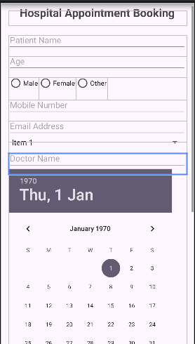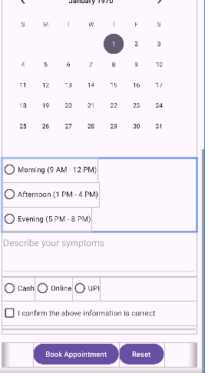 | CO2 | N
5. | Implement the Explicit and implicit Intent. Make use of the form design for Hospital Appointment Booking Form created in practical 4. Create a Second Activity that takes the data passed from MainActivity of the application and perform the various actions using implicit intent as shown below.  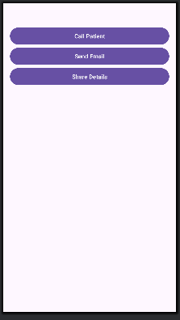 | CO2 | N
6. | Design an Online Quiz Application that Display  at least 3 questions and use radio buttons to store user response.  On click of Submit->a dialog must pop up asking the user "Are you sure you want to Submit?" with action buttons Yes and Cancel. Clicking Cancel will dismiss the dialog. Clicking Yes will submit the quiz, calculate the score and send a Notification saying "Your test results are ready". Attach a pending intent to the Notification which will open an Activity2 that displays the test result.  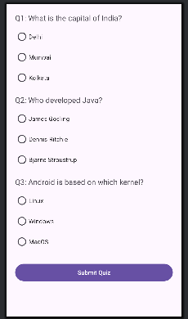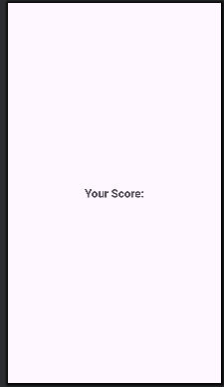 | CO2 | N
7. | Demonstrate the use of Shared Preference in Android Application  To design and implement a responsive Organ Donation Registration Android application that demonstrates the use of SharedPreferences and Internal Storage. The application should allow the user to enter their signup details only once, storing them in a SharedPreferences file so that the signup page is skipped in subsequent launches. Additionally, the application should use internal storage to record organ donation registration details and provide a count of different organ types registered by reading the stored file contents.  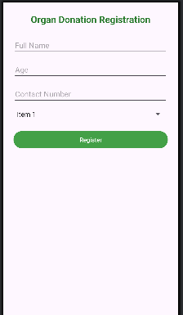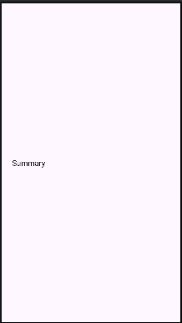 | CO3 | N
8. | Problem Statement: Design an activity for STUDENT REGISTRATION FORM . Design a form to accept roll number, name and marks of the student. On click of REGISTER button create/open existing database, and store the information entered by student in the student table. Also place a RESET button to reset all fields and a VIEW ALL APPLICATIONS button to display all rows of the student table.  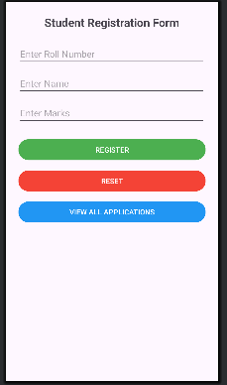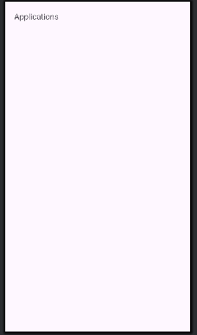 | CO3 | N

